**THE FISRT DAY**

1.Look and write

|  |
| --- |
| get dressed comb my hair have a shower have breakfast  get up go to school catch the bus brush my teeth |

|  |  |  |  |
| --- | --- | --- | --- |
|  | Káº¿t quáº£ hÃ¬nh áº£nh cho get dressed clipart | Káº¿t quáº£ hÃ¬nh áº£nh cho brush teeth clipart | HÃ¬nh áº£nh cÃ³ liÃªn quan |
| *.* |  |  |  |
| Káº¿t quáº£ hÃ¬nh áº£nh cho get up clipart | HÃ¬nh áº£nh cÃ³ liÃªn quan | HÃ¬nh áº£nh cÃ³ liÃªn quan | Káº¿t quáº£ hÃ¬nh áº£nh cho comb my hair clipart |
|  | *.* |  |  |

2. Read and circle the corrct words.

|  |  |  |
| --- | --- | --- |
| * He **gets/ get** up early. | * We **catch/catches** the bus. | * Tony **have/has** breakfast with his family. |
| * Lisa **brushes/brush** her teeth every morning. | * I **have /has** shower every day. | * **Do/does** you go to school everyday ? |
| * She **have /has** breakfast every morning. | * **Do/Does** they catch the bus every morning ? | * They **go /goes** to school everyday. |
| * Anna **don’t/doesn’t** catch the bus. | * What time **do/does** Toby go to school? | * **Do/Does** they brush their teeth at night ? |
| * He **don’t/doesn’t** walk to school. | * My sister **get/gets** up at six o’clock. | * **Do/Does** she have a shower at night ? |

3.Look at the table.Are the sentences true or false? Write **T** or **F** , then write sentences.

|  |  |  |  |  |
| --- | --- | --- | --- | --- |
|  | Ben | Lily | Toby | Anna |
| get up early | ✓ | 🗶 | 🗶 | ✓ |
| go to school by car | 🗶 | 🗶 | ✓ | ✓ |
| play tennis | ✓ | ✓ | 🗶 | 🗶 |
| get dressed at 8 o’clock | 🗶 | ✓ | 🗶 | 🗶 |

|  |  |  |
| --- | --- | --- |
| 1. Ben gets up early. | **T** | **He gets up early.** |
| 1. Lily goes to school by car. |  | **She doesn’t go to school by car.** |
| 1. Toby doesn’t play tennis. |  |  |
| 1. Anna gets dressed at 8 o’clock. |  |  |
| 1. Ben goes to school by car. |  |  |
| 1. Lily plays tennis. |  |  |
| 1. Toby gets up early. |  |  |
| 1. Anna goes to school by car. |  |  |

**THE SECOND DAY**

4.Complete the sentences.

|  |
| --- |
| Sunday is Lily’s favorite day. She usually gets up ( get up) at ten o’clock , then she ___________( have ) a big breakfast with her family.  After that,she always _______ ( go ) for a long walk in the park.She usually ___________( meet) her friends and they sometimes ________(play) tennis  In the afternoon, Lily ________ (watch ) TV or __________ (listen ) to music. Then, In the evening she always ___________(visit ) her grandparents and they usually ________(have) dinner together.  Lily always look forward to Sundays! |

5.Read and complete the sentences. Use the correct form of the verbs.

|  |
| --- |
| Watch get up brush sleep study clean go listen feed have wash catch comb |

* Ben always **gets up** at 7 o’clock.
* Jill and Kim always ______________ after school.
* Eric and Sue sometimes ______________ TV in the afternoon.
* Helen always _____________ her teeth in the morning.
* John sometimes ____________ in the morning.
* Jill __________ her bedroom at the weekend.
* Toby ___________ to the cinema on Fridays.
* My sister _________ to music every day.
* Tom _________ his dog every day.
* I __________ a guitar lesson on Tuesdays.
* Tom and Mary __________ their face in the morning.
* We __________ the bus every morning
* My brother ________ his hair every morning.

6.Complete the sentences with correct adverbs.

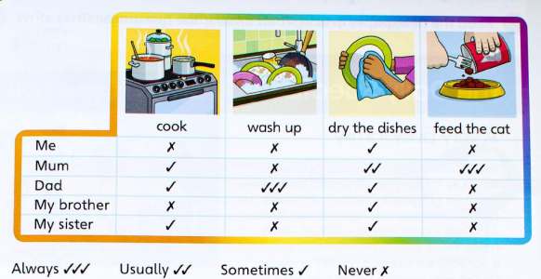

* I never feed the cat.

1. Mum ____________ dries the dishes.
2. Dad _____________ washes up.
3. My brother _______________ dries the dishes.
4. My sister_____________ washes up.
5. My brother ______________ feeds the cat.
6. I _______________ cook.
7. My sister_______________ dries the dishes.
8. I _______________ cook.
9. Mum ______________ feeds the cat.
10. My brother _______________ cooks.
11. My sister ______________ feeds the cat.
12. Dad ______________ feeds the cat.

**THE THIRD DAY**

7. Put the words in the correct order to make sentences.

|  |  |
| --- | --- |
| I /at /7 o'clock/ in/ the /morning./get/up. | She/to/goes/school/at /9 o'clock/ in /the/ morning./ |
|  |  |
| Anna/to/sleep/ at /10 o'clock/ at night./go | I /at/ 5 o'clock/ in /the/afternoon./watch/TV |
|  |  |
| At/ 4 o'clock/ in /the/afternoon./She/does/her/homework/ | What/do/you/time /get /up ?/ |
|  |  |
| Does /he/have/in /the/morning?/breakfast | They/ catch / bus /the/every/ morning ./ |
|  | *.* |
| Lisa/ to /school /by/ car./goes | Julia /up/ at/ 6:30 /on/ Tuesdays. /gets |
|  |  |
| Does/go/to /school/by /car ?/he/ | have /dinner/I /at/ seven/o’clock./ |
|  |  |
| Do/swimming/they/go /on/Tuesdays?/ | I /my/hair/comb/seven /o’clock./at |
|  | *..* |
| What/does/she/to/school?/go/time | Does/your/sister/breakfast/have/every day ? |
|  |  |

8.Look at Kim’s fact file about her daily routine and complete the paragraph.

|  |  |
| --- | --- |
| **Getting up time** : 7:00  **Routines** : have a shower , comb hair , get dressed  **Breakfast** : a bread  **School time** : from 8:30 to 3  **Transport** : bus  **Routines before dinner** : do home work and listen to music  **After dinner** : read , watch TV , chat with friends online  **Go to bed time** : 9:30 | On school days I get up at _____________ .I go to the bathroom. I ___________ and comb my hair. Then I ________________.  and go downstairs for breakfast . I usually eat _______________.At 8 o’clock I catch the _________ to school.  I have lessons from _____________ .When I come back home, I usually ______________ and then I ________________  I have dinner with my family at 7:30 and then I ______________or _______________ I go to bed at _____________ |

9.Complete the questions using the correct form of **have.**

* **Does** your Dad **have** a car ?
* ___________ he ___________ breakfast every day ?
* ___________ you___________ a shower in the evening ?
* ___________ your family ___________ dinner together?
* ___________ they ___________ lots of friends ?
* ___________ we ___________ a lot of homework ?
* ___________ I ___________ long hair ?
* ___________ Anna ___________ lots of toys ?

**THE FOURTH DAY**

10.Look and answer the questions.

|  |  |  |
| --- | --- | --- |
|  |  |  |
|  |  |  |
| **What time does he get up ?** | What time does he have breakfast? | What time does he brush his teeth ? |
| ***He gets up at seven o’clock..*** | *.* |  |
|  |  |  |
|  |  |  |
| What time does he have a shower ? | What time does he comb his hair ? | What time does he get dressed ? |
|  |  |  |
|  |  |  |
|  |  |  |
| What time does he prepare his bag ? | What time does he put on his coat ? | What time does he go to school ? |
|  | *.* |  |

11.Find the mistakes and correct them.

|  |  |
| --- | --- |
| He **get** up at six o c’lock every morning. | They **goes** to school by bus. |
| He **gets** up at six o c’lock every morning. | They **go** to school by bus. |
| What time do she get up every day ? | Lily and Anna usually has breakfast with their family. |
|  |  |
| We sometimes goes to the cinema. | He have dinner at six o’clock with his family. |
|  |  |
| She goes to work on eight o’clock in the morning. | She go to bed at ten o’clock. |
|  |  |
| Emma get up at nine o’clock on Saturdays. | Lucy brush his teeth in the morning . |
|  |  |
| He play in the park at eight o’clok. | She have lunch at twelve o’clock. |
|  |  |
| What time does you go to bed ? | I brushes my teeth after dinnner. |
|  |  |
| My father never go to bed early | Sophia cook chicken with rice at the weekends. |
|  |  |
| Kelly and Tim washes their car every Friday afternoon. | We visits our grandparents every week. |
|  |  |

12.Read about Leila’s daily routine and answer the questions in complete statements.

Example: What does she usually do in the morning?

She usually waters the plants.

Leila has a busy life but she handles it very well. Every morning, she always gets up at 6:00 a. m because she has to prepare breakfast for the family. Then, she has to work in the school from 8:00 a.m. to 3:00 p.m. She teaches the teenagers. After that, she gets home and takes a shower and eats a pizza. Then, she waters the plants. She loves gardening. She has a special project in her garden. She is planting flowers and vegetables. She has never planted spices but she is planning to do it sooner. She sometimes watches a movie with the family. She usually cooks dinner for the family but, she often goes out to eat at a local Italian or Chinese restaurant. She loves lasagna and the kids love pizza. On weekends, they occasionally visit the family. But they always go to church.

|  |
| --- |
| QUESTIONS |
| 1.what time does she get up?  *……………………………………………………………………….* |
| 2.Why does she get up early in the morning?  *……………………………………………………..* |
| 1. What does she do ? *………………………………………………………………………* |
| 1. When do they visit the family? *………………………………………………………………………* |
| 1. What does she always do on weekends?   *………………………………………………………* |

**THE FIFTH DAY**

13.Odd one out

|  |  |  |  |
| --- | --- | --- | --- |
| 1. table tennis | 1. football | 1. guitar | 1. volleyball |
| 1. teacher | 1. doctor | 1. nurse | 1. man |
| 1. go | 1. wash | 1. brush | 1. nice |
| 1. Monday | 1. February | 1. April | 1. August |
| 1. June | 1. Friday | 1. Saturday | 1. Sunday |
| 1. Winter | 1. Spring | 1. Windy | 1. Autumn |
| 1. ruler | 1. folder | 1. rubber | 1. pencil |
| 1. bus | 1. bike | 1. car | 1. taxi |
| 1. math | 1. English | 1. science | 1. field trip |
| 1. long | 1. bored | 1. parrot | 1. curious |
| 1. hammer | 1. warm | 1. clear | 1. relaxed |
| 1. ruler | 1. sharpener | 1. pen | 1. apple |
| 1. flute | 1. bell | 1. piano | 1. drum |

14.Look , read and tick (✓) or cross (🗶)

|  |  |
| --- | --- |
|  | The man is eating a hamburger. ✓  The dog has got a sausage.  The woman is standing at the window.  There’s a radio under the chair.  Two children are playing table tennis.  There are two birds in the big tree.  The boy is bouncing a ball. |

15.Look , read and write.

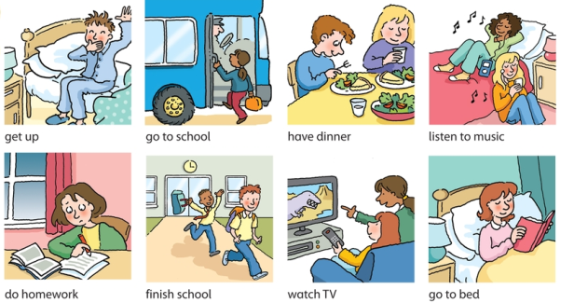

1. I get up at six o’clock.
2. Sally _____________up at seven o’clock.
3. I ___________ my homework in the morning.
4. Sally _________ her homework in the evening
5. I ___________ school by bus.
6. Sally ___________ school by car.
7. We ___________ school at three o’clock.
8. We ______________ dinner at 6.30 p.m.
9. I _________________TV in the evening.
10. Sally _______________ to music.
11. I _________________________ to bed at nine o’clock.
12. Sally_________________________ to bed at ten o’clock.

**THE SIXTH DAY**

1. **Vocabulary**

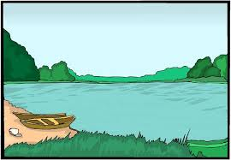……………….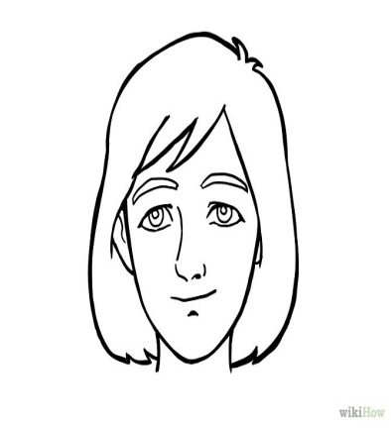……….......

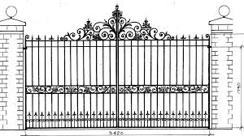……………………………..

1. **Write plural words from singular ones**
2. Foot→
3. Dress→
4. Beach→
5. Dish→
6. Glass→
7. Boy→
8. Day→
9. Apple→
10. Egg→
11. Church→
12. Person→
13. Orange→
14. Man→
15. Bus→
16. Fly→
17. Animal→
18. Watch→
19. Hotel→
20. City→
21. lunch→

**III. fill a/ an/ X**

1. ………………..purple
2. ……………….new books
3. ……………….good teacher
4. ……………….red pen
5. …………….....blue table
6. ………………umbrella
7. ……………….ticket
8. ……………….island
9. ………………pencils
10. ………………coats

**THE SEVENTH DAY**

1. **Preposition: at, by, to, on, for :**
2. I get up …………………. 6 o’clock …………………the morning
3. He is a doctor, he works ………………..night.
4. Let’s listen ………………….music.
5. What have we got ………………..Monday?
6. It is time …………………..football.
7. Put ………………your PE clothes now.
8. **There is/there are/are there/is there:**
9. ……………………a beach down here.
10. …………………….four girls and two boys in her family.
11. …………………….a train to Manchester?
12. ……………………a new disco near the collage.
13. …………………..a good restaurant in this street?
14. …………………...two hospitals in town.
15. ……………………a lot of children in the pool?
16. …………………..three families in that house.
17. …………………..a television in the flat?
18. …………………..a big grey cloud over there.
19. **Subject and object pronouns(1pts)**
20. Can you help **we/us** with these bags?
21. **We/us** usually see **they/them** at the weekend.
22. How did you teach **he/him** to read?
23. **I/me** write to see **her/she** once a month.
24. Please don’t wait for **us/we**.
25. Would you like to come with **I/me**.

**THE EIGHTH DAY**

1. **Translate :**

My mum is a doctor. She starts work at six o’clock, so I don’t see her in the morning. She goes home at two o’clock and she cooks dinner. I see my mum in the afternoon and the evening.

………………………………………………………………………………………………………………………………………………………………………………………………………………………………………………………………………………………………………………………………

1. **Choose the best answer:**
2. She ………………..to bed at 9 o’clock.
3. getes B. gets C. go D. goes
4. He ………………..dinner at 6 o’clock.
5. Have B. has C. get D. gets
6. I ……………..my coat.
7. Go B. goes C. take D. takes
8. She ………………….dressed.
9. Have B. has C. get D. gets

**IV. Write about your Tet Holidays**